John T. Broderick, Jr.

From Chief Justice to Mental Health Crusader
John T. Broderick, Jr. is the senior director of External Affairs at Dartmouth-Hitchcock Health (D-HH). Prior to joining D-HH, he was a member of the New Hampshire Supreme Court from 1995 to 2010, serving as chief justice from 2003 to 2010. During his time on the Court, the Broderick family experienced the devastating impacts of mental illness in a very public way.
For years, Broderick’s eldest son struggled with addiction, which had masked a severe underlying mental health issue. One evening, that struggle manifested itself in an assault that nearly cost Broderick his life, and sent his son to prison.
As a family they survived and healed, and now use their experience to help educate others that mental illness is not something to be ashamed of. Rather, it is something to be recognized and to be addressed just as any physical illness would be.
Mental Health Crusader – R.E.A.C.T.
“This is the most important and meaningful work of my career.”
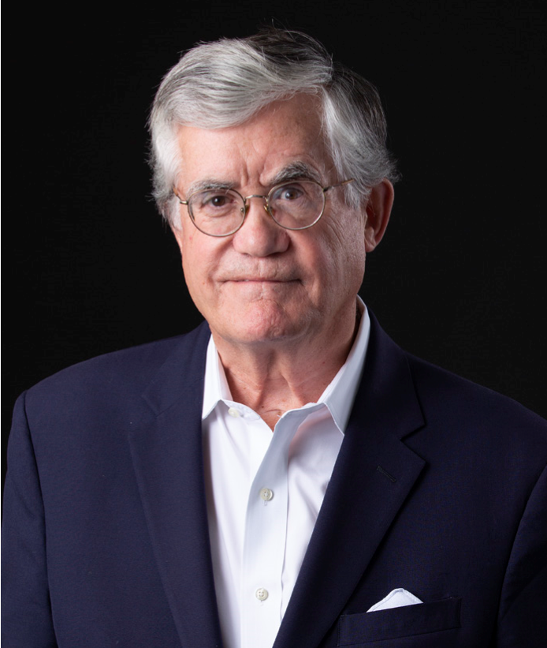
In 2016, after having served as New Hampshire co-chair of national mental health awareness Campaign to Change Direction, Broderick helped to create D-HH’s R.E.A.C.T campaign. This powerful public awareness campaign represents the steps people can take when they recognize that they or someone they care about is experiencing mental health challenges.
In just over three years, Broderick has spoken more than 500 times to more than 100,000 high school and college students, business leaders and their employees, senior citizens and veterans. He has driven more than 80,000 miles crisscrossing New Hampshire, Vermont, Maine and Massachusetts in an effort to improve understanding and awareness of mental illness, to eliminate its stigma and to encourage discussion. His family’s personal experience with undiagnosed and untreated mental illness is the driving force behind his dedication to share the 5 Signs/R.E.A.C.T messages with audiences and Broderick says this is the most important and meaningful work of his career.
Broderick’s efforts have received widespread media coverage and have inspired programs such as a statewide high school poster campaign with the New Hampshire Interscholastic Athletic Association’s “Life of an Athlete” program; a statewide, and much heralded, two-day Youth Summit in which nearly 350 teens gathered to tackle difficult issues through discussion, workshops and art; the “99 Faces Project” a nationally-traveling multi-media art exhibit by artist Lynda Cutrell, designed to reduce the stigma of mental illness which was accompanied by mental health programming at Dartmouth-Hitchcock Medical Center; and more. His family’s journey was recently captured in a powerful documentary produced by Dartmouth-Hitchcock.
Broderick has spoken alongside countless luminaries, political figures and business executives including the chief justices of the New Hampshire and Vermont Supreme Courts, the attorneys general of Vermont and New Hampshire and their staffs, former CEO of Proctor & Gambel and former U.S. Secretary of Veteran’s Affairs Bob McDonald, and executives from Johnson & Johnson and Booz Allen Hamilton, among many others.
John T. Broderick, Jr.
John T. Broderick, Jr. became the senior director of External Affairs at Dartmouth-Hitchcock Health (D-HH) in 2017. He was a member of the New Hampshire Supreme Court from 1995 to 2010. During his last seven years as chief justice, much of his focus was on court reform in an effort to make the justice system in our state more accessible, affordable and understandable for more of our citizens. He was the first chief justice in New Hampshire’s history to appoint a Citizens Commission on the State Courts so that citizens could examine how the courts functioned and how they could be improved to better serve those who needed them. John created the first-ever business court and first ever Office of Mediation and Arbitration embedded in the New Hampshire Judicial branch. He also expanded the family court, mental health court and drug court dockets across the state.
After stepping down as chief justice, he became dean of the Law School at the University of New Hampshire. Under his leadership, the law school advanced an unprecedented 49 slots in the U.S. News and World Report rankings into a tie with the law schools at Northeastern University and Villanova University. John was also the founder of the Warren B. Rudman Center for Justice, Leadership and Public Policy at the law school.
Before entering public service, John was a civil trial lawyer in private practice for more than twenty years and formerly served as president of both the New Hampshire Bar Association and the New Hampshire Trial Lawyers Association. He is a fellow of the American College of Trial Lawyers. John has received numerous professional awards and several honorary degrees.
In 2016, after agreeing to co-chair the first statewide launch in New Hampshire of a national mental health awareness campaign called Change Direction New Hampshire, he began his work with D-HH. Taking on the mission of mental health awareness, he began leading and speaking about the D-HH R.E.A.C.T. campaign. John has spoken more than 500 times to various audiences about the five most common signs of mental illness in an effort to improve understanding and awareness of mental illness to eliminate its mythology, to encourage discussion and treatment and to begin to change the unfair and shameful culture that surrounds it.
John was born in Norwood, MA. He is an honors graduate of College of the Holy Cross in Worcester, MA, and the University of Virginia Law School, Charlottesville, VA. John is married, has two adult sons and four grandchildren.
Engaging with John Broderick and D-HH
Broderick and D-HH’s R.E.A.C.T. campaign goals are simple, timely and important: to make the five most common signs of mental illness as well and widely known as the signs of a heart attack or stroke, and to teach people how to react when they recognize the signs of mental illness in someone they know or love.
With support from D-HH, John Broderick willingly shares his family’s mental health journey and highlights the struggles posed by mental illness for so many families.

If you are interested in learning more about this effort or having John speak to you organization, please contact Karen J. Borgstrom, director of External Affairs for Dartmouth-Hitchcock at karen.j.borgstrom@hitchcock.org.
Facts & Figures |  | *Statistics from: www.nami.org/mhstats
- 1 out of 5 adults will •  experience a mental health challenge during their lifetime.  - ½ of all mental illness arises •  before age 14 and ²⁄³ by age 23.  - Suicide is the second leading • cause of death among teenagers.  - In 2019 alone 45,000 people •  in the United States took their own lives; 6,000 were military veterans.  - Almost every 90 minutes an •  American veteran is lost to suicide. | 1 in 5 U.S. adults experience • mental illness each year  1 in 25 U.S. adults  experience serious mental •  illness each year  1 in 6 U.S. youth aged 6-17 experience a mental health disorder each year  •  50% of all lifetime mental  illness begins by age 14, and  75% by age 24  •  Suicide is the 2nd leading cause of death among people  aged 10-34 |  | 19.1% of U.S. adults experienced mental illness in 2018 (47.6 million people). This represents 1 in 5 adults.  4.6% of U.S. adults experienced serious mental illness in 2018 (11.4 million people). This represents 1 in 25 adults.  16.5% of U.S. youth aged 6-17 experienced a mental health disorder in 2016 (7.7 million people).  3.7% of U.S. adults experienced a co-occurring substance use disorder and mental illness in 2018 (9.2 million people).
R.E.A.C.T. Statistics
Since 2016...
- Averaging over 175 presentations annually • Averaging over 25,000 miles driven annually to and from schools and other venues
- Averaging over 35,000 in attendance annually
A selection of venues where John has spoken include:

- NH Department of Justice
- NH Endowment for Health
- NH Police Convention
- NH Association of School Principals
- Vermont Attorney Generals Retreat
- Vermont Medical Society
- NHIAA Leadership Conference
- Clinical Mental Health Program SNHU
- Massachusetts School Nurses Conference
- New England School Superintendents’ meeting
- Northeast Delta Dental
- AARP Nashua, NH
- NH Hospital Association
- Association of New Hampshire Public Employer HR Administrators
- New England Alliance for Mental Health

